Assignment – 12
##Using the operators ANY, ALL and SOME.
1) Write a query that selects all customers whose ratings are equal to or greater than
ANY of Serres’.
Ans--
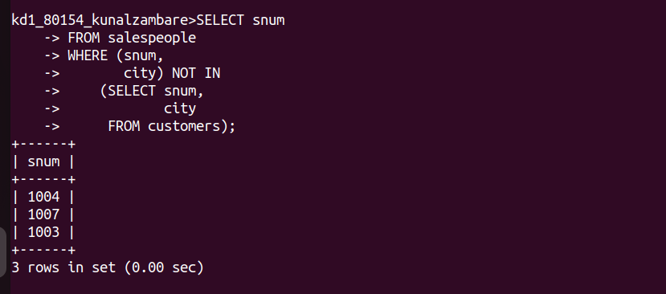
2) Write a query using ANY or ALL that will find all salespeople who have no
customers located in their city.
Ans--
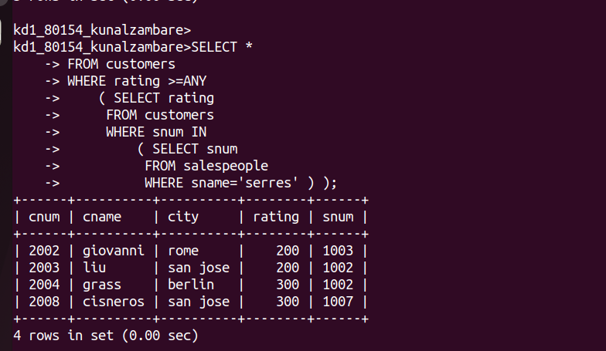
3) Write a query that selects all orders for amounts greater than any for the
customers in London.
Ans--
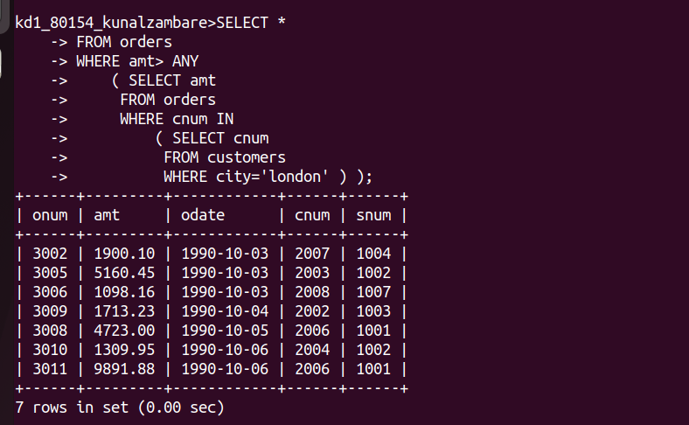

4) Write the above query using MIN or MAX.
Ans--
